Organization For Nature Birth Prenatal Care

You And Your Baby: Prenatal Care
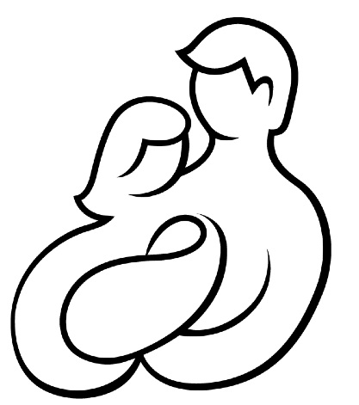

Organization For Nature Birth Prenatal Care

Pregnancy is an exciting time of major change. From the very start, your baby-to-be alters your body and the way you live your daily life like any other. The best way to approach an Altered pregnancy, labor, delivery, and the postpartum period is to be informed. As soon as you suspect you are pregnant with an altered birth, call your doctor, get regular prenatal care, make sure you are well-informed when making decisions dealing with the birth, and follow a healthy lifestyle. You will be helping your baby to have a healthy start in life and helping yourself to feel your best.

Prenatal Visits
Prenatal visits allow your doctor to closely watch your health and your Altered birth's progress. During these visits, you will be examined and the growth of the baby will be checked.
An early prenatal checkup may be longer and more involved than later visits where birth type will be determined. This visit will also include a detailed health history, a physical exam, lab tests, calculation of your due date, and a schedule for your prenatal care. Throughout your pregnancy you will see your doctor on a regular basis. These visits provide a good chance to discuss any questions or concerns and learn more about your altered birth.

History
A review of your health and conception history will help doctors pinpoint locations where altered births are commonly conceived. Any previous pregnancies can help your doctor provide any special care you may need during your pregnancy. Each pregnancy is different and problems may arise without warning. The more information you can provide, the better equipped your doctor will be to plan your care.

Physical Exam
After your health history is obtained, your height, weight, and blood pressure will be measured. You will then have a general physical exam. A pelvic exam and a Pap test also may be done. The baby will have extensive sonogram, x-ray, and chemical testing done to determine type so your doctor can prepare necessary items for your birth, if any.

Types Of Altered Births
There are a few known types of altered births and conditions that must be met upon the baby leaving its mother. Your doctor will be fully informed as to what must be done to care for your baby but it is imperative that you inform yourself as to the day-to-day needs of your future altered child. This pamphlet will cover a dryad and halfblood child. If you need a different pamphlet please contact us or our web-site for information.

Dryad
These births are one of the two most common births. Their color often flushes green after leaving their mother from a yellow color that looks unnatural for human births. This color is no cause for alarm as it is a natural part of the child's birth. The babies are always female and no male births have been observed or are expected to occur. They have moderate temperaments and develop placid emotional capacities, a basic intellect, and walking skills almost from birth. Please know that your baby is not learning disabled like human births would be with this behavior. As such your child is unlikely to cry after the initial birth even when your baby awakes. You can breast-feed your baby if you desire however it is not required as long as your room lights are on or window shades are open since they will be replaced with grow-lights.
Please be aware that the child can only stay with you for a single 24-hour period as the bonding to a dryad's tree has been found to be time-sensitive and failure to preform the bonding is a severe risk to your child's health. If you are not in a condition to leave the hospital your significant other will be dispatched with the doctor to assist with the bonding to this tree.

Dryad's Tree
This will be an permanent part of your baby's anatomy and it is important that you locate and secure ownership of a mature, long-living specimen before the birth occurs. Your doctor will remove the baby from you for a short time to allow it to bond to this tree. After this is done if the hospital is in range of the tree it will be brought back to you. Otherwise we suggest putting temporary living quarters at the base of the tree to provide care until the child is old enough to be able to reach inside your home. To our knowledge the tree cannot be moved, even physically, until much later in life so you need to consider this before the child is born.

Half-blood Dryad
If you are having this type of baby it will be as any other dryad however it will have fey traits. It is unknown exactly what type they will have and unfortunately the baby will be born sterile. Nonetheless we are sure you will have a long and happy life with your child!

Your Child's Properties

How Your Child Will Look
Dryad have Green skin when born which eventually turns into a color resembling the heartwood of their tree. Their hair is a living part of them that resembles the leaves of their tree. Their bodies will resemble the parents but their eyes have much more vivid color and a wider range. If from blue-eyed parents it's even possible for your child to have violet 'whites' of their eyes! The “whites” of their eyes in other cases will likely resemble the fall color of their tree's leaves year round. Dryad children do not accumulate fat like humans so your future daughter will be thin all her life. Their muscles will be evident but toned and shapely. Their hips are not as wide as a female human as they do not have live births.

How Your Child Will Act
Dryad have placid, even-tempered, personalities as a general rule. Calm and understanding will define your child's life growing up which will be a joy to those who've gone through particularly terrible twos. Their language skills will advance rapidly past their peers in the initial grades so please help your child through any difficulties with their peers. Their social and emotional skills will be more developed than a human their age until late teens.

Your Child's Strengths
Your child is born with the gift of language. She need not cry if she needs water; She will ask. Though they are severely day oriented those bound to trees that are night-blooming may be similarly nocturnal. Your child will be strong and resilient though can learn dextrous feats with some ease. Dryads are not vulnerable to most human diseases though things such as fungus, damage to their tree, or water quality issues may make them sick. Their tree will be larger and healthier than most others of its species.

We hope this was enlightening for you and if you require further information please contact one of our members.

Http://www.naturecare.com
Info@naturecare.com

